# 

**4.2: Deep Neural Networks** **1**

4.2.1: Data and Tasks 1

4.2.2: Model 3

4.2.2a: A Simple Deep Neural Network 3

4.2.2b: A Generic Deep Neural Network 7

4.2.2c: Understanding the Computations in a Deep Neural Network 9

4.2.2d: The Output Layer of a Deep Neural Network 11

4.2.2e: Output Layer of a Multi-Class Classification Problem 12

4.2.2f: How do you choose the right Network Configuration 14

4.2.3: Loss function 16

4.2.3a: Loss function for Binary Classification 16

4.2.3b: Loss function for Multi-Class Classification 18

4.2.4: Learning Algorithm (Non-Math version) 20

4.2.5: Evaluation 21

4.2.6: Summary 22

# 

# Deep Neural Networks

## Data and Tasks

What kind of data and tasks have DNNs been used for?

1. One common example is digit classification using the MNIST dataset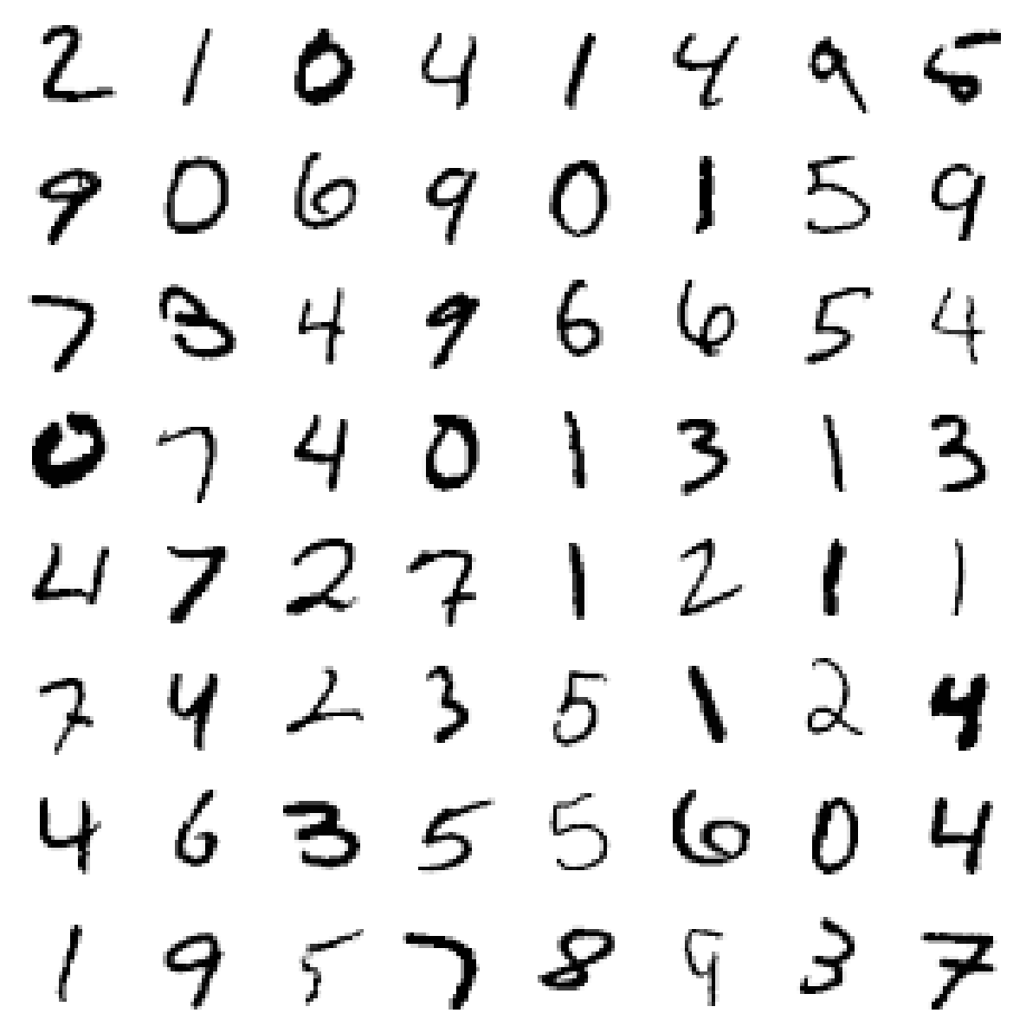
   1. MNIST images are vectorized using the pixel values of each cell
   2. Matrix having pixel values will be of size 28x28 (as MNIST images are of the size 28x28)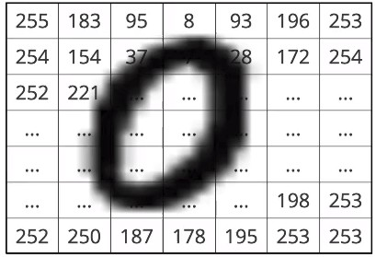
   3. Each pixel can range from 0 to 255. Standardise pixel values by dividing with 255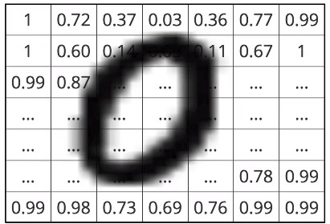
   4. Now, flatten the matrix to convert into a vector of 784 (28x28)
2. Convert all images to vectors of order ℝ784
3. Let’s look at the data along with the labels (Multi-Class Classification)

|  |  |  |  |
| --- | --- | --- | --- |
| **28x28 images** | **Vectorized form** | **Class Label** | **Class Labels - One Hot Representation** |
|  | [1.00, 0.72, … 0.99] | 0 | [1,0,0,0,0,0,0,0,0,0] |
|  | [1.00, 0.85, … 1.00] | 1 | [0,1,0,0,0,0,0,0,0,0] |
|  | [1.00, 0.76, … 1.00] | 2 | [0,0,1,0,0,0,0,0,0,0] |
|  | [0.99, 0.82, … 1.00] | 3 | [0,0,0,1,0,0,0,0,0,0] |
|  | [0.73, 0.81, … 0.67] | 4 | [0,0,0,0,1,0,0,0,0,0] |
|  | [1.00, 1.00, … 0.99] | 5 | [0,0,0,0,0,1,0,0,0,0] |
|  | [0.84, 0.72, … 0.99] | 6 | [0,0,0,0,0,0,1,0,0,0] |
|  | [0.33, 0.52, … 1.00] | 7 | [0,0,0,0,0,0,0,1,0,0] |
|  | [0.85, 0.72, … 0.99] | 8 | [0,0,0,0,0,0,0,0,1,0] |
|  | [0.84, 0.92, … 0.99] | 9 | [0,0,0,0,0,0,0,0,0,1] |

1. Another example would be the Indian Liver Patient classification problem. There are only two possible outcomes, hence it is a Binary-Class classification task
2. An example for regression would be Housing Price Prediction, where instead of predicting a discrete output, the prediction is a real-number or continuous value (decimals, fractions etc)

## Model

### 

### A Simple Deep Neural Network

How to build complex functions using Deep Neural Networks

1. Consider the previously used example of mobile phone like/dislike predictor with the variables Screen-size and Cost. It has a complex decision boundary as shown here
2. With a single sigmoid neuron, it is impossible to obtain this shape, regardless of how we vary the parameters w & b, as the sigmoid neuron can only produce a shape ranging from s-shaped to flat. The formula is

|  |  |
| --- | --- |
| **Sigmoid decision boundary, can range from s-shaped to flat, based on w and b values** | |
|  | |
|  |  |

1. Now, let us consider a Deep Neural Network for the same mobile phone like/dislike predictor
2. Breaking down the model:
   1. x1 = Screen-Size, x2 = Cost
   2. First Neuron *h1 = f1(x1,x2)* or
      1. Here, w11 and w12 are the weights of x1 and x2 corresponding to the first neuron h1
      2. b11 is the corresponding bias
   3. Second Neuron *h2 = f2(x1,x2)* or
      1. Here, w13 and w14 are the weights of x1 and x2 corresponding to the second neuron h2
      2. b12 is the corresponding bias
   4. Output Neuron *ŷ = g(h1,h2)* or
      1. Here, w21 and w22 are the weights of h1 and h2 corresponding to the output neuron ŷ
      2. b21 is the corresponding bias
   5. From this configuration, we have 9 parameters (w11,w12,w13,w14,w21,w22, b1, b2, b3), which allow for a much more complex decision boundary than a single sigmoid neuron with 3 parameters
3. The output would look something like this

|  |  |
| --- | --- |
| **Deep Neural Network Decision Boundary, more complex than a single sigmoid neuron.** | |
|  | |
|  |  |
| * This simple neural network already allows for a much better decision boundary than with a single sigmoid neuron | |

1. The next step would be figuring out how to choose the best configuration of the DNN for our task, this is called **Hyperparameter Tuning.**
2. For now, we can rest easy knowing that by the **Universal Approximation Theorem** we will be able to approximate any kind of function with our Neural Network

### 

### A Generic Deep Neural Network

Can we clarify the terminology used?

1. Let us revisit the structure of a neuron
2. Let us break down the terms
   1. Let i refer to the layer being referenced
   2. **Pre-activation function**
   3. **Activation function** a
   4. Here, the activation function is the sigmoid function.
   5. The construction of a Neural network is a simple stacking of these neurons in layers, one on top of the other
   6. The outputs of one layer of neurons become the inputs for the next layer.
   7. The cycle of pre-activation and activation repeats itself from the input layer, till we reach the output layer and obtain the desired function
3. Let us break down the structure of a Neural Network
4. Let’s break down some of the terms used:
   1. The format of w is W(Layer number)(Next layer Neuron)(Current Layer Input/neuron)
      1. So W213 refers to the weight corresponding to the 3rd input on 1st neuron of the 2nd hidden layer
   2. For each layer i where 0 <= i <= L
      1. Pre-activation
      2. Activation where ‘*g’* is called the activation function
      3. Activation at output layer L is where ‘O’ is called the output activation function

### 

### Understanding the Computations in a Deep Neural Network

Let’s look at the computations inside a DNN

1. Consider the same DNN drawn in the previous section
2. The preactivation outputs for the first layer a11, a12 a13, are calculated using simple Matrix-vector multiplication

|  |  |  |  |  |  |  |  |  |  |
| --- | --- | --- | --- | --- | --- | --- | --- | --- | --- |
|  |  | w111 | w112 | w113 |  |  |  | x1 |  |
| W1= | w121 | w122 | w123 | X= | x2 |
|  | w131 | w132 | w133 |  | x3 |

1. Here, the preactivation values are as follows
   1. These values are just the individual rows of the dot-product between W1 and X plus the bias vector
   2. Thus W1X = a1 is given by

|  |  |  |  |
| --- | --- | --- | --- |
|  |  | a11 |  |
| a1 = | a12 |
|  | a13 |

* 1. Here, W1∊ℝ3x3, X∊ℝ3x1, and W1X∊ℝ3x1

1. The activation values are as follows
   1. They are simply the result on applying the activation function (in this case: sigmoid) on the preactivated values

### 

### The Output Layer of a Deep Neural Network

How do we decide the output layer?

1. Here are the dimensions of our values
   * 1. ai ∊ ℝm
     2. Wi ∊ ℝmxn
     3. xi ∊ ℝnx1
     4. bi ∊ ℝm
     5. hi ∊ ℝm
2. Here is a quick sample
3. Here, it is possible to write the output function ŷ completely in terms of x
4. Here ŷ ∊ ℝK where K is the number of output units

### Output Layer of a Multi-Class Classification Problem

Deciding the output layer

1. The Output Activation function is chosen depending on the task at hand (can be a softmax, linear etc)
2. Consider the following multi-class classification problem
3. At the last layer, we compute a3 = W3h2 + b3
4. We need to apply a function to ŷi = O(a3i) such that the 4 outputs form a probability distribution.
5. Output activation function has to be chosen such that the output is probability.
6. Let’s assume a3 = [3 4 10 3]
   1. Take each entry and divide by the sum of all entries to get a probability distribution
   2. However, **this will not work** if any of the entries are negative
7. So we consider the softmax function
8. for i = 1...k
9. Note: the output of ex is always positive, irrespective of the input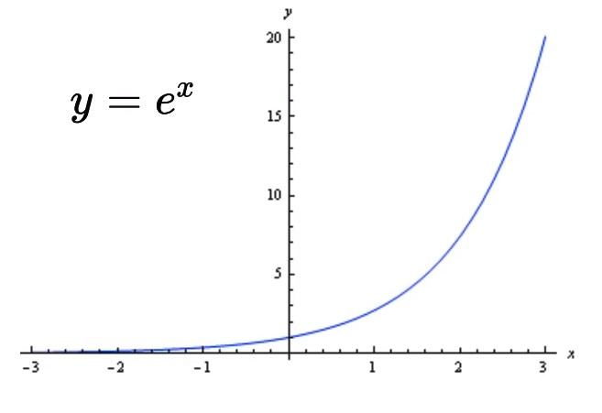
10. This property is important to counter the negative-value shortcoming that we observed in the previous example
11. Now, let us illustrate the softmax function at the last layer of our Neural Network
12. Raising the numerators to ex ensures that they are all positive
13. The denominator is just the sum of all the values raised to ex
14. So for our multi-class fruit classifier, the equations are as follows

|  |  |  |
| --- | --- | --- |
| **Layer** | **Pre-activation** | **Activation/Output** |
| Hidden Layer 1 |  |  |
| Hidden Layer 2 |  |  |
| Output Layer |  |  |

### 

### How do you choose the right Network Configuration

In practice how would you deal with extreme non-linearity

1. Consider the following datasets, 2D and 3D

|  |  |  |
| --- | --- | --- |
| **Dimension** | **Data** | |
| 2D |  |  |
| 3D |  | |

1. Up to 3D, we can visualise our data to check if it is linearly-separable or not.
2. However, in real-life scenarios, datasets often approach 1000-10000 dimensions, so there is no way to visualise the data to ascertain non-linearity.
3. In order to choose the best configuration for our neural network, we need to try out different combinations and select the one with the lowest loss
4. Here are some sample configurations and their corresponding losses

|  |  |  |  |
| --- | --- | --- | --- |
|  |  |  |  |
|  | | | |

1. From the above figures, it is evident that the fourth yields the lowest loss.
2. This process of tuning the DNN i.e. The No. of layers, No. of neurons in each layer, learning rate, batch size etc are together called **Hyperparameter Tuning**

## 

## Loss function

### Loss function for Binary Classification

What is the loss function that you can use for a binary classification problem

1. In normal cases, the number of neurons in the output layer would be equal to the number of classes
2. However a shortcut in the case of binary classification would be to use only one output neuron that uses a sigmoid function. Here is a diagrammatic representation of that configuration
3. Here, ŷ = P(y = 1)
4. Therefore, we can obtain P(y = 0) = 1 - P(y = 1)
5. Consider the following values for the variables
   1. y = 1

|  |  |  |  |  |  |  |
| --- | --- | --- | --- | --- | --- | --- |
|  |  | 0.9 | 0.2 | 0.4 | 0.3 |  |
| W1= | -0.5 | 0.4 | 0.3 | 0.3 |
|  | 0.1 | 0.1 | -0.1 | 0.2 |
|  | -0.2 | 0.5 | 0.5 | / |

* 1. W2 = [0.5 0.8 -0.6 0.3]
  2. x = [0.3 0.5 -0.4 0.3]

1. The output values are as follows
   1. In this case
   2. Cross Entropy Loss:
      1. In this case, since y = 1
2. Consider another case where x = [-0.6 -0.6 0.2 0.3] and true class y = 1
3. The output values are as follows
   1. In this case
   2. Cross Entropy Loss:
      1. In this case, since y = 0
      2. Here, even though the true value was 0, our neuron was outputting a very large value(0.7152) which was already indicative of a large loss value.

### 

### Loss function for Multi-Class Classification

What is the loss function that you can use for a multi-class classification problem

1. Here is an illustration of a sample multi-class classification Neural Network
2. Consider the following values for the parameters
   1. b = [0 0]

|  |  |  |  |  |  |  |
| --- | --- | --- | --- | --- | --- | --- |
|  |  | 0.1 | 0.3 | 0.8 | -0.4 |  |
| W1= | --0.3 | -0.2 | 0.5 | 0.5 |
|  | -0.3 | 0.1 | 0.5 | 0.4 |
|  | 0.2 | 0.5 | -0.9 | 0.7 |

|  |  |  |  |  |  |  |
| --- | --- | --- | --- | --- | --- | --- |
|  |  | 0.3 | 0.8 | -0.2 | -0.4 |  |
| W2= | 0.5 | -0.2 | -0.3 | 0.5 |
|  | 0.3 | 0.1 | 0.6 | 0.6 |

1. Consider a case where x = [-0.6 -0.6 0.2 0.3] and true class y =[0 1 0]
2. The output values are as follows
   1. Cross Entropy Loss
3. Consider another case where x = [0.6 0.4 0.6 0.1] and true class y =[0 0 1]
4. The output values are as follows
   1. Cross Entropy Loss
5. A quick summary of what we’ve learned so far
   1. Given weights, we know how to compute the model’s output for a given input
   2. This is called Forward-propagation.
   3. Given weights, we know how to compute the model’s loss for a given input
   4. But who will give us the weights?
6. The weights can be obtained from the learning algorithm

## 

## Learning Algorithm (Non-Math version)

Can we use the same Gradient Descent algorithm as before

1. We will be looking at the non-math version of the learning algorithm
2. Consider the following Neural Network
3. The algorithm
   1. **Initialise:** w111, w112, … w313, b1, b2, b3 randomly
   2. **Iterate over data**
      1. Compute ŷ
      2. Compute L(w,b) Cross-entropy loss function
      3. w111 = w111 - η𝚫w111
      4. w112 = w112 - η𝚫w112

…

* + 1. w313 = w111 - η𝚫w313
    2. bi = bi + η𝚫bi
    3. Pytorch/Tensorflow have functions to compute
  1. **Till satisfied**
     1. Number of epochs is reached ( ie 1000 passes/epochs)
     2. Continue till Loss < ε (some defined value)

## 

## Evaluation

How do you check the performance of a deep neural network

1. Consider the Indian Liver Patient Diagnosis task

|  |  |  |  |  |  |
| --- | --- | --- | --- | --- | --- |
| Age | Albumin | T_Bilirubin | ……  More features | y | ŷ |
| 65 | 3.3 | 0.7 | 0 | 0 |
| 62 | 3.2 | 10.9 | 0 | 1 |
| 20 | 4 | 1.1 | 1 | 1 |
| 84 | 3.2 | 0.7 | 1 | 0 |

1. The question here is, how do we resolve a probability distribution like [0.45 0.55] to a binary output
2. It is done by picking the class that corresponds to the highest probability, in the above case it is 1.
3. For multiclass classification, the concept remains the same. The label is selected based on the highest value in the probability distribution.
4. The predicted label corresponds to the index of the highest value in the probability distribution (argmax)

|  |  |  |
| --- | --- | --- |
| **Test Data** | **y** | **Predicted** |
|  | 0 | 0 |
|  | 1 | 7 |
|  | 3 | 8 |
|  | 5 | 5 |
|  | 1 | 1 |

1. In addition to accuracy, we can also calculate the per-class accuracy. In this case, the accuracy of the class **‘1’**  is 50% and of class **‘5’** is 100%
2. This allows us to analyse where the model is performing poorly, and enables us to take steps to improve the accuracy for the lagging classes, such as adding more images etc.

## 

## Summary

What are the new things that we learned in this module?

1. Here are some of the takeaways from this chapter
   1. Data: Real inputs ℝ
   2. Task:
      1. Binary classification
      2. Multi-class classification
      3. Regression
   3. Model: Deep Neural Network to deal with complex decision boundaries
   4. Loss:
      1. Cross entropy loss:
      2. Square Error Loss:
   5. Learning: Gradient Descent with backpropagation
   6. Evaluation:
      1. Accuracy =
      2. Per-class Accuracy =
2. Note: the text highlighted in red indicates concepts that will be covered in the upcoming chapters.
3. 